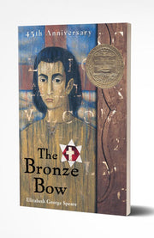
THE BRONZE BOW

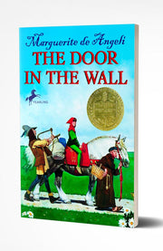
THE DOOR IN THE WALL

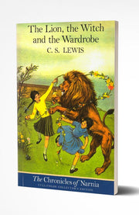
THE LION, THE WITCH, & THE WARDROBE

CRISPIN, THE CROSS OF LEAD

THE SECRET GARDEN

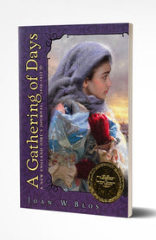
A GATHERING OF DAYS

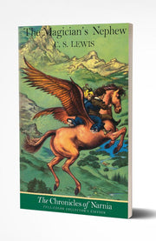
THE MAGICIAN'S NEPHEW

NUMBER THE STARS

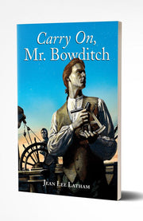
CARRY ON, MR. BOWDITCH

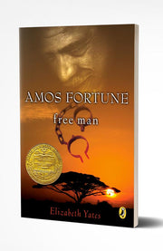
AMOS FORTUNE, FREE MAN

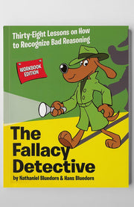
THE FALLACY DETECTIVE (WORKBOOK EDITION)
THE MAGICIAN'S NEPHEW

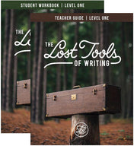
THE LOST TOOLS OF WRITING, LEVEL 1 (TEACHER SET)
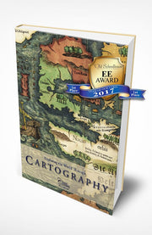

EXPLORING THE WORLD THROUGH CARTOGRAPHY

ANALOGIES FOR ALL OF US

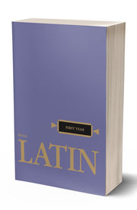
HENLE FIRST YEAR LATIN (TEXT)

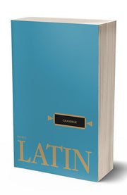
HENLE LATIN GRAMMAR

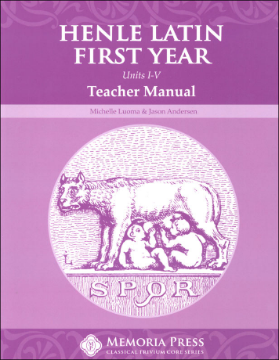
HENLE LATIN FIRST YEAR TEACHER MANUAL (ANSWER KEY)

